**BUS RESERVATION SYSTEM**

### A Project Work

*Submitted in the partial fulfillment for the award of the degree of*

# BACHELOR OF ENGINEERING

### IN

### BIG DATA ANALYTICS

### Submitted by:

### KUNAL SHARMA (20BCS3999)

### Under the Supervision of:

### Ms. Deepinder kaur



# DEPARTMENT OF COMPUTER SCIENCE AND ENGINEERING APEX INSTITUE OF TECHNOLOGY

### CHANDIGARH UNIVERSITY, GHARUAN, MOHALI - 140413,

**PUNJAB**

#### MARCH 2022

#### Date: 27 July 2021

**Place: Chandigarh University**

# Table of Contents

**page**

|  |  |  |
| --- | --- | --- |
|  | Abstract  List of Tables  List of Figures | 3 |
| 4 |
| 5 |
|  |
|  |
|  |
|  |
| **1.** | **INTRODUCTION\*** | 6 |
|  | * 1. Problem Definition   2. Project Overview/Specifications*   3. Hardware   1.3.1 Laptop or pc  1.4 Software Specification  1.4.1 Operating System: Windows  1.4.2 Toolkit: HTML  1.4.3CSS to style webpages  1.4.4 Javascript  1.4.5 PHP | 6  6  7  7  7  7-8  8.  9  10 |
| 1. **LITERATURE SURVEY**    1. Existing System    2. Proposed System    3. Feasibility Study 2. **PROBLEM FORMULATION**    1. project planning    2. Use case diagram    3. UML Diagrm | | 13 |
| 13  13  14 |
| 15  15-16  16-17  17-22      23  23  24  24  25-28    29  30 |
|  | |
| 1. **OBJECTIVES**   **4.1 Analysis**   1. **METHODOLOGY**   5.1 Project Design  5.2 Project snapshots   1. **RESULTS AND DISCUSSION** 2. **REFERENCES** | |

**Abstract**

An Online Bus Reservation System, is a website that facilitates travel and online ticket purchase. A reservation system is a webpage that is utilized in a bus transportation system for reservation of seats, cancelling a seat reservation and querying client and bus information, as well as previous reservations. about several types of routes for an immediate reservation. This software is designed for an online ticketing system that uses data from its database, ticket booking and bus tracking, and obtaining the best price for clients based on their ratings. it is built for managing and computerizing the traditional database, ticket booking and tracking bus and travel made. It maintains all customer details, bus details, reservation details.

The software was developed using HTML and CSS for the front end, and Apache MySQL, and Xampp for the back end. Our website was built with the goal of enhancing consumer convenience and comfort. We have ensured that, despite the software's performance, an addition from our end is the use of e-mail to send tickets to customers after booking and online payment, which eliminates the need for cash.

## List of Tables

##### Table Title page

***2.1*** *Table of comparison( between existing system and proposed system)* ***14***

.

## List of Figures

##### Figure Title page

1. *Use case diagram of Your Way Bus 15*
2. *UML of Bus Reservation system 17*
3. *UML of Login page 19*
4. *Login page snapshot 25*
5. *PNR enquiry snapshot 26*
6. *Query Box snapshot 27*
7. *Admin page snapshots. 28*

# INTRODUCTION

* 1. **Problem Definition**

Currently, the type of system being used at the counter is an internal system which is manually used in selling the bus tickets. The problems facing the company are that customers have to go to the counter to buy bus ticket or ask for bus schedule, customers will also have to queue up for a long time in order to secure a bus ticket and will also need to pay cash when they buy the bus ticket.

**1.2 Overview**

The main objective of the Project on Bus Ticket Booking System is to manage the details of Bus, Tickets, Booking, Customer, Seats. It manages all the information about Bus, Seats. The project is totally built at administrative end and thus only the administrator is guaranteed the access. The purpose of the project is to build an application program to reduce the manual work for managing the Bus, Tickets, Agent, Booking. It tracks all the details about the Booking, Customer, Seats.

Specifically, objectives of this project will consist of:

1. Providing a web-based bus ticket reservation function where a customer can buy bus ticket through the online system without a need to queue up at the counter to purchase a bus ticket.
2. Enabling customers to check the availability and types of busses online. Customer can check the time departure for every bus through the system.
3. Ability of customers to cancel their reservation.
4. Admin user privileges in updating and canceling payment, route and vehicle records.
5. it tracks all the information of Tickets, Customer etc
6. Manage the information of Tickets
7. Shows the information and description of the Bus, Booking
8. To increase efficiency of managing the Bus, Tickets
9. It deals with monitoring the information and transactions of Customer.
10. Manage the information of Bus and information of Customer.
11. Editing, adding and updating of Records is improved which results in proper resource management of Bus data.

**1.3** **Hardware Requirements:**

**1.3.1 Laptop or PC**

A laptop, laptop computer, or notebook computer is a small, portable personal computer (PC) with a screen and alphanumeric keyboard. These typically have a "clamshell" form factor, typically having the screen mounted on the inside of the upper lid and the keyboard on the inside of the lower lid, although 2 in 1 Pcs with a detachable keyboard are often marketed as laptops or as having a "laptop mode." Laptops are folded shut for transportation, and thus are suitable for mobile use. Its name comes from lap, as it was deemed practical to be placed on a person's lap when being used. Today, laptops are the used in a variety of settings, such as at work, in education, for playing games, web browsing, for personal multimedia, and general home computer use.

* 1. **Software Requirements**:

The Software Requirements Specification is produced at the culmination of the analysis task. The function and performance allocated to software as part of system engineering are refined by establishing a complete information description, a detailed functional and behavioral description, an indication of performance requirements and design constraints, appropriate validation criteria, and other data pertinent to requirements.

**1.4.1 Operating System: Windows**

1.4.1.1 Windows 7

Windows 7 is the Microsoft Windows operating system (OS) released commercially in October 2009 as the successor to Windows Vista. Windows 7 is built on the Windows Vista kernel and was intended to be an update to the Vista OS. It uses the same Aero user interface (UI) that debuted in Windows Vista. As a result, to many end users, the biggest changes between Vista and Windows 7 were faster boot times, new UIs and the addition of Internet Explorer ([IE](https://searchenterprisedesktop.techtarget.com/definition/Internet-Explorer)) 8. The OS is widely available in three retail editions: Windows 7 Home Premium, Professional and Ultimate. Starter, Home Basic and Enterprise editions are available in some markets. In development, Windows 7 was known by the code names Blackcomb and Vienna.

1.4.1.2 Windows 8

The successor of Windows 7 will support beside of the 32 bit and 64-bit Intel and AMD SoC (system-on-a-chip) architectures also ARM for a widest possible range of form factors on the market. NVIDIA, Qualcomm and Texas Instruments are working on different SoC designs based on the ARM architecture:  
 - Snapdragon ARM system from Qualcomm  
 - OMAP ARM system from Texas Instruments

- Tegra ARM system from NVIDIA with main focus to high-performance graphic  
Microsoft is porting basic-applications like the Internet Explorer and Office applications to the new platform. They are native ARM applications for Windows 8.

1.4.1.3 Windows 10

Windows 10 is a major version of the Microsoft [Windows](https://techterms.com/definition/windows) operating system that was released on July 29, 2015. It is built on the Windows NT [kernel](https://techterms.com/definition/kernel) and follows windows 8

Part of the reason Microsoft decided to name the 2015 release "Windows 10" (and skipped "Windows 9") is because the [operating system](https://techterms.com/definition/operating_system) is designed to be a new direction for Microsoft. One of the primary aims of Windows 10 is to unify the Windows experience across multiple devices, such [desktop computers](https://techterms.com/definition/desktop_computer), [tablets](https://techterms.com/definition/tablet), and [smartphones](https://techterms.com/definition/smartphone). As part of this effort, Microsoft developed Windows 10 Mobile alongside Windows 10 to replaces Windows Phone – Microsoft's previous mobile OS.

**1.4.2. HTML for web development**

HTML is a markup language heavily utilized for creating web pages and web applications. HTML, when combined with JavaScript and CSS, has become a milestone for web development. One of the useful aspects of HTML is, it can embed programs written in a scripting language like JavaScript, which is responsible for affecting the behaviour and content of web pages. CSS inclusion would affect the layout and appearance of the content. The basic building blocks of any HTML pages are HTML elements. A structured document can be created with the help of structural-semantic text like heading, paragraph, list, link, and other items. Browser indeed does not display the HTML tags but utilize them to interpret the content of the page. One needs to study various tags and then understand their behaviour.

**1.4.3. CSS to style webpages**

CSS is used for defining the styles for web pages. It describes the look and formatting of a document which is written in a markup language. It provides an additional feature to HTML. It is generally used with HTML to change the style of web pages and user interfaces.

It is easier to make the web pages presentable using CSS. It is easy to learn and understand and used to control the presentation of an HTML document. CSS helps us to control the text color, font style, the spacing between paragraphs, sizing of columns, layout designs, and many more. It is independent of HTML, and we can use it with any XML-based markup language.

It is recommended to use CSS because the HTML attributes are being deprecated. So, for making HTML pages compatible with future browsers, it is good to start using CSS in HTML pages

**1.4.4. javascript for making interactive webpage**

JavaScript is a text-based programming language used both on the client-side and server-side that allows you to make web pages interactive. Where HTML and CSS are languages that give structure and style to web pages, JavaScript gives web pages interactive elements that engage a user. Common examples of JavaScript that you might use every day include the search box on Amazon, a news recap video embedded on The New York Times, or refreshing your Twitter feed.

Incorporating JavaScript improves the user experience of the web page by converting it from a static page into an interactive one. To recap, JavaScript adds behaviour to web pages.

Developers can use various JavaScript frameworks for developing and building web and mobile apps. JavaScript frameworks are collections of JavaScript code libraries that provide developers with pre-written code to use for routine programming features and tasks—literally a framework to build websites or web applications around.

**1.4.5**  **PHP (main coding language)**

PHP stands for Hypertext Preprocessor (no, the acronym doesn't follow the name). It's an open source, server-side, scripting language used for the development of web applications. By scripting language, we mean a program that is script-based (lines of code) written for the automation of tasks.

What does open source mean? Think of a car manufacturer making the secret to its design models and technology innovations available to anyone interested. These design and technology details can be redistributed, modified, and adopted without the fear of any legal repercussions. The world today might have developed an amazing supercar!

Web pages can be designed using HTML. With HTML, code execution is done on the user's browser (client-side). On the other hand, with PHP server-side scripting language, it's executed on the server before it gets to the web browser of the user.

PHP can be embedded in HTML, and it's well suited for web development and the creation of dynamic web pages for web applications, e-commerce applications, and database applications. It's considered a friendly language with abilities to easily connect with MySQL, Oracle, and other databases.

PHP scripts can be used on most of the well-known operating systems like Linux, Unix, Solaris, Microsoft Windows, MAC OS and many others. It also supports most web servers including Apache and IIS. Using PHP affords web developers the freedom to choose their operating system and web server.

In PHP, server-side scripting is the main area of operation. Server-side scripting with PHP involves:

PHP Parser: a program that converts source and human readable code into a format easier for the computer to understand

Web server: a program that executes files that form web pages from user requests

Web browser: an application used to display content on the World Wide Web

In this instance, with the use of just a PHP parser, the PHP script can be executed without a server program or browser. This use of the PHP script is normally employed for simple text processing tasks, like task schedulers.

PHP can also be used for creating client-side applications, like desktop applications. Desktop applications are usually characterized by a graphic user interface. With knowledge in using the advanced features of PHP, such as PHP-GTK, these client-side applications can be developed.

**1.4.6. Visual studio**

Visual Studio is an Integrated Development Environment(IDE) developed by Microsoft to develop GUI(Graphical User Interface), console, Web applications, web apps, mobile apps, cloud, and web services, etc. With the help of this IDE, you can create managed code as well as native code. It uses the various platforms of Microsoft software development software like Windows store, Microsoft Silverlight, and Windows API, etc. It is not a language-specific IDE as you can use this to write code in C#, C++

Visual Studio (like any other IDE) includes a code editor that supports syntax highlighting and code completion using IntelliSense for variables, functions, methods, loops, and LINQ queries. IntelliSense is supported for the included languages, as well as for XML, Cascading Style Sheets, and JavaScript when developing web sites and web applications.

**1.4.7 Bootstrap**

Bootstrap is a free and open source front end development framework for the creation of websites and web apps. The Bootstrap framework is built on HTML, CSS, and JavaScript (JS) to facilitate the development of responsive, mobile-first sites and apps.

Responsive design makes it possible for a web page or app to detect the visitor’s screen size and orientation and automatically adapt the display accordingly; the mobile first approach assumes that smartphones, tablets and task-specific Mobile apps are employees' primary tools for getting work done and addresses the requirements of those technologies in design.

Bootstrap includes user interface components, layouts and JS tools along with the framework for implementation. The software is available precompiled or as source code.

In computers, the word bootstrap means to boot: to load a program into a computer using a much smaller initial program to load in the desired program (which is usually an operating system).

In the physical world, a bootstrap is a small strap or loop at the back of a leather boot that enables you to pull the entire boot on and in general usage, bootstrapping is the leveraging of a small initial effort into something larger and more significant. There is also a common expression, "pulling yourself up by your own bootstraps," meaning to leverage yourself to success from a small beginning.

**1.4.8 APACHE**

As a Web server, Apache is responsible for accepting directory (HTTP) requests from Internet users and sending them their desired information in the form of files and Web pages. Much of the Web’s software and code is designed to work along with Apache’s features. Programmers working on Web applications typically make use of a home version of Apache to preview and test code.

**1.4.9 XAMPP**

XAMPP helps a local host or server to test its website and clients via computers and laptops before releasing it to the main server. It is a platform that furnishes a suitable environment to test and verify the working of projects based on Apache, Perl, MySQL database, and PHP through the system of the host itself. Among these technologies, Perl is a programming language used for web development, PHP is a backend scripting language, and MariaDB is the most vividly used database developed by MySQL. The detailed description of these components is given below.

**1.4.10 SVG File**

An SVG file is a graphic saved in a two-dimensional vector graphic format created by the World Wide Web Consortium (W3C). It stores information that describes an image in a text format that is based on XML. SVG files may include vector shapes, embedded raster graphics (also known as bitmap images), and text.

1. **LITERATURE REVIEW**

**2.1 Existing System**

In the present Bus Ticket Reservation System, the work is maintained by the manual process, so the user needs to contact the person related to each branch for the inquiry to get the details such as the schedule of a bus, seat availability, bus facility, cost, etc. In the current Bus Ticket Reservation System, the time is limited by the working hour of the branch and the person who want to buy the ticket has to go to the branch. The company keeps all the records related to bus ticket manually to calculate the income which is not an easy process. While there will be a probability of error in calculation.

**2.2 Proposed System**

The Bus Ticket Reservation System will provide an easy way to access the information of any bus. By use of this system a user can check the ticket availability, can know the time of bus departure. While it will provide options such as a user can buy the ticket online, can make payments, can cancel the tickets. As the ticket is online generated it cannot be lost while the user can access the system 24 hours and seven days in a week which make the system user-friendly. It will also manage the information of the user and the bus expense so that a company can use these to analyze the profit from it.

**2.3 Feasibility study**

A feasibility analysis usually involves a thorough assessment of the operational (need), financial. and technical aspects of a proposal. Feasibility study is the test of the system proposal made to identify whether the user needs may be satisfied using the current software and hardware technologies, whether the system will be cost effective from a business point of view and. whether it can be developed with the given budgetary constraints. A feasibility study should be. relatively cheap and done at the earliest possible time. Depending on the study, the decision is made whether to go ahead with a more detailed analysis. When a new project is proposed, it normally goes through feasibility assessment. Feasibility study is carried out to determine whether the proposed system is possible to develop with available resources and what should be the cost consideration.

Facts considered in the feasibility analysis were

1. Technical Feasibility

Technical feasibility includes whether the technology is available in the market for development and its availability. The assessment of technical feasibility must be based on an outline design of system requirements in terms of input, output, files, programs and procedures. This can be qualified in terms of volumes of data, trends, frequency of updating, cycles of activity etc, in order to give an introduction of technical system. Considering our project it is technical feasible

1. Economic Feasibility

This feasibility study present tangible and intangible benefits from the project by comparing the development and operational cost. The technique of cost benefit analysis is often used as a basis for assessing economic feasibility. This system needs some more initial investment than the existing system, but it can be justifiable that it will improve quality of service.

1. Behavioral Feasibility

This analysis involves how it will work when it is installed and the assessment of political and managerial environment in which it is implemented. People are inherently resistant to change and computers have been known to facilitate change. The new proposed system is very much useful to the users and therefore it will accept broad audience from around the world

Table.1

|  |  |  |
| --- | --- | --- |
| **Parameters** | **Existing System** | **Proposed** **System** |
| Method | Manual | Automatic |
| Time | more | less |
| Accuracy | accurate | more accurate |
| complexity | Less complex | Less complex |

# PROBLEM FORMULATION

**3.1 Project planning and scheduling is a part of project management.**

The project planning stage requires several inputs, including conceptual proposals, project schedules. The development of this project is not successfully done without proper planning and scheduling. Project planning and scheduling is very important stage for us.

(a) **Analysis:**

The maximum time for analysis phase of this will take project around 10 days.

(b) **Design:**

The maximum time for design phase of this project will take around 15 days.

(c**) Implementation:**

The maximum time for implementation phase of this project will take around 14 days.

(d) **Testing:**

The maximum time for testing phase of this project will take around is 8 days.

**3.2 Use Case Diagram**

A use case diagramat its simplest is a representation of a user's interaction with the system that shows the relationship between the user and the different use cases in which the user is involved. A use case diagram can identify the different types of users of a system and the different use cases and will often be accompanied by other types of diagrams as well. The use cases are represented by either circles or ellipses.

3.2.1 Actor

An Actor models a type of role played by an entity that interacts with the subject (e.g., by exchanging signals and data), but which is external to the subject (i.e., in the sense that an instance of an actor is not a part of the instance of its corresponding subject). Actors may represent roles played by human users, external hardware, or other subjects. Note that an actor does not necessarily represent a specific physical entity but merely a particular facet (i.e., "role") of some entity that is relevant to the specification of its associated use cases. Thus, a single physical instance may play the role of several different actors and, conversely, a given actor may be played by multiple different instances.

3.2.2 Association

An association specifies a semantic relationship that can occur between typed instances. It has at least two ends represented by properties, each of which is connected to the type of the end. More than one end of the association may have the same type.

3.2.3 System

If a subject (or system boundary) is displayed, the use case ellipse is visually located inside the system boundary rectangle. Note that this does not necessarily mean that the subject classifier owns the contained use cases, but merely that the use case applies to that classified.

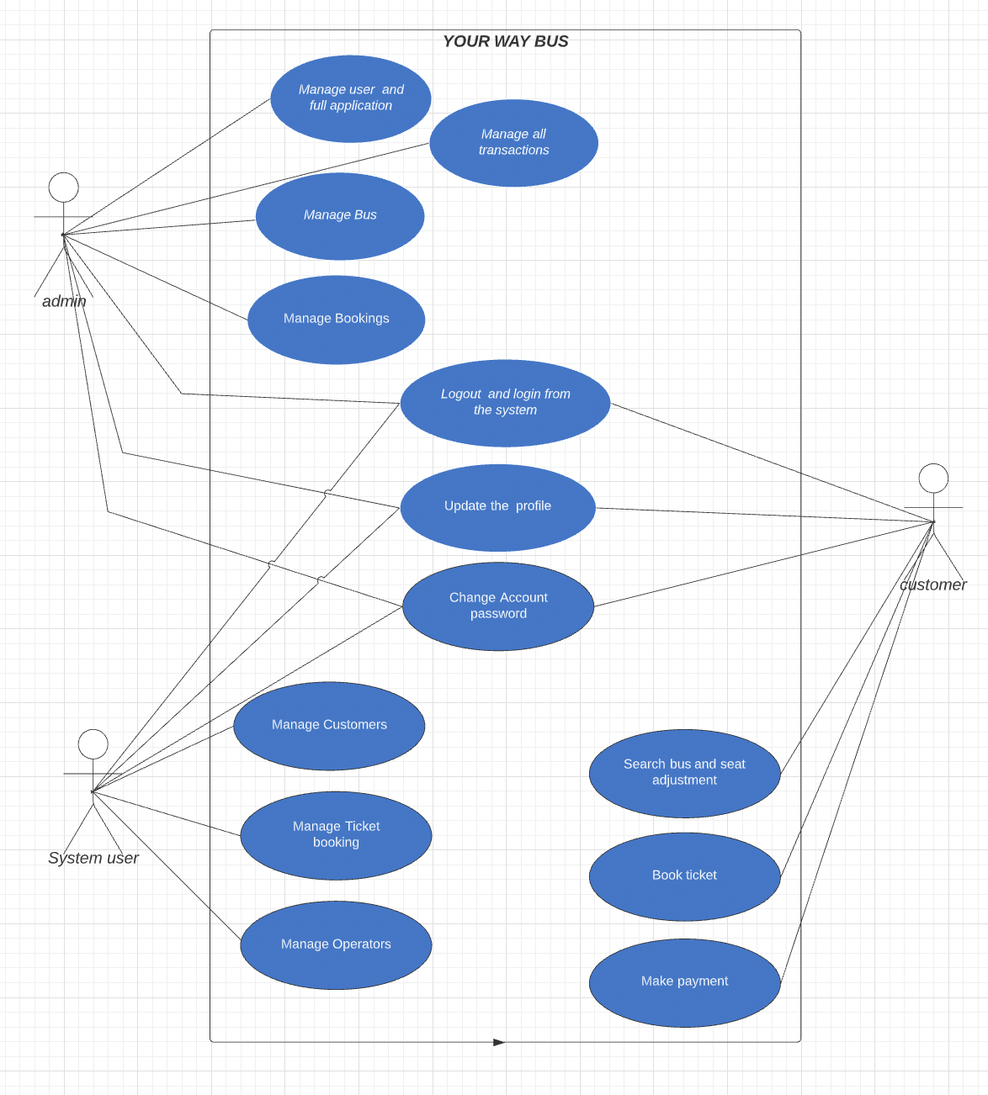

Figure 1.Use Case Diagram

**3.3 UML Diagram**

The  (UML) can help you model systems in various ways. One of the more popular types in UML is the class diagram. Popular among software engineers to document software architecture, class diagrams are a type of structure diagram because they describe what must be present in the system being modeled. No matter your level of familiarity with UML or class diagrams, our  is designed to be simple and easy to use.

UML was set up as a standardized model to describe an object-oriented programming approach. Since classes are the building block of objects, class diagrams are the building blocks of UML. The various components in a class diagram can represent the classes that will actually be programmed, the main objects, or the interactions between classes and objects.

The class shape itself consists of a rectangle with three rows. The top row contains the name of the class, the middle row contains the attributes of the class, and the bottom section expresses the methods or operations that the class may use. Classes and subclasses are grouped together to show the static relationship between each object.

The UML shape library in Lucidchart can help you create nearly any custom class diagram using our UML diagram tool.

3.3.1 Actor

An Actor models a type of role played by an entity that interacts with the subject (e.g., by exchanging signals and data), but which is external to the subject (i.e., in the sense that an instance of an actor is not a part of the instance of its corresponding subject). Actors may represent roles played by human users, external hardware, or other subjects. Note that an actor does not necessarily represent a specific physical entity but merely a particular facet (i.e., "role") of some entity that is relevant to the specification of its associated use cases. Thus, a single physical instance may play the role of several different actors and, conversely, a given actor may be played by multiple different instances. Since an actor is external to the subject, it is typically defined in the same classifier or package that incorporates the subject classifier

3.3.2 Call Message

A message defines a particular communication between Lifelines of an Interaction. Call message is a kind of message that represents an invocation of operation of target life line . Messages are arrows that represent communication between objects. Use half-arrowed lines to represent asynchronous messages. Asynchronous messages are sent

from an object that will not wait for a response from the receiver before continuing its

tasks.

3.3.3 Lifelines  
 Life line are vertical dashed lines that indicate the object's presence over time.

3.3.4 **Destroying Objects**  
 Object can be terminated early using an arrow labelled "<< destroy >>" that points to an X.

This object is removed from memory. When that object's lifeline ends, you can place an X

at the end of its lifeline to denote a destruction occurrence.

**3.3.5 Loops**  
 A repetition or loop within a sequence diagram is depicted as a rectangle. Place the

condition for exiting the loop at the bottom left corner in square brackets

* 1. **Package Diagrams**

Package diagrams are structural diagrams used to show the organization and arrangement of various model elements in the form of packages. A package is a grouping of related UML Elements such as diagrams, documents, classes, or even other packages. Each element is nested within the package, which is depicted as a file folder within the diagram, then arranged hierarchically within the diagram. Package diagrams are most commonly used to provide a visual organization of the layered architecture within any UML classifier, such as a software system.

3.4.1 **Package**

A namespace used to group together logically related elements within a system.

Each element contained within the package should be a packageable element and

have a unique name.

* + 1. **Packageable element**

A named element, possibly owned directly by a package. These can include events, components, use cases, and packages themselves. Packageable elements can also be rendered as a rectangle within a package, labeled with the appropriate name.

* + 1. **Dependencies**

A visual representation of how one element (or set of elements) depends on or influences another. Dependencies are divided into two groups: access and import dependencies.

* + 1. **Element import**

A directed relationship between an importing namespace and an imported packageable element. This is used to import select individual elements without resorting to a package import and without making it public within the namespace.

* + 1. **Package import**

A directed relationship between and importing namespace and an imported package. This type of directed relationship adds the names of the members of the imported package to its own namespace

* + 1. **Package merge**

A directed relationship in which the contents of one package are extended by the contents of another. Essentially, the content of two packages are combined to produce a new package.

**3.5 Class Diagram**

A template for creating objects and implementing behavior in a system. In UML, a class represents an object or a set of objects that share a common structure and behavior. They're represented by a rectangle that includes rows of the class name, its attributes, and its operations. When you draw a class in a class diagram, you're only required to fill out the top row—the others are optional if you'd like to provide more detail. Depending on the context, classes in a class diagram can represent the main objects, interactions in the application, or classes to be programmed.

3.5.1 Name

The first row in a class shape.

3.5.2 **Attributes**

The second row in a class shape. Each attribute of the class is displayed on a

separate line. Attributes are shown in the second partition. The

attribute type is shown after the colon. Attributes map onto member

variables (data members) in code.

* + 1. **Methods**

The third row in a class shape. Also known as operations, methods are displayedin

list format with each operation on its own line. Operations are shown in the third

partition. They are services the class provides. The return type of a method is

shown after the colon at the end of the method signature. The return type of

method parameters is shown after the colon following the parameter name.

Operations map onto class methods in code

* + 1. Generalization

Generalization is a relationship between two classes: a general class and a

special class:

3.5.5 Association

An association represents a relationship between two classes. An association

indicates that objects of one class have a relationship with objects of another class,

in which this connection has a specifically defined meaning (for example, “is flown

with”).

3.5.6 Multiplicity

A multiplicity allows for statements about the number of objects that are

involved in an association.

3.5.7 Aggregation

An aggregation is a special case of an association (see above) meaning “consists

Of”.

**3.6 Features Of The Activity UML Diagram Of Bus Booking System**

• Admin User can search Customer, view description of a selected Customer, add Customer, update Customer and delete Customer.

• Its shows the activity flow of editing, adding and updating of Ticket

User will be able to search and generate report of Route, Booking, Bus

• All objects such as (Customer, Ticket, Bus) are interlinked

• Its shows the full description and flow of Customer, Booking, Bus, Route, Ticket

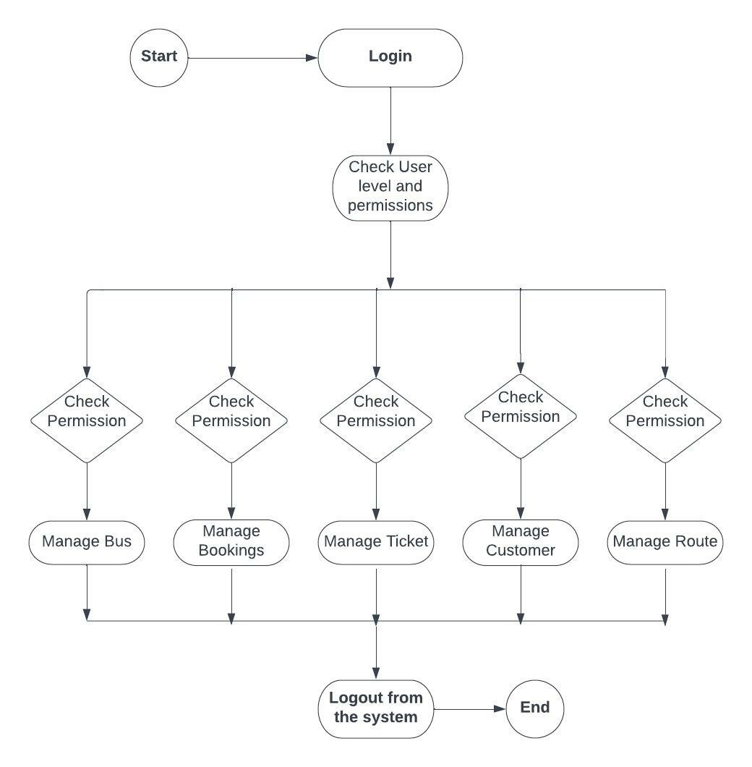

Figure 2. UML of Bus Reservation system

**3.7 Login Activity Diagram Of Bus Booking System:**

This is the Login Activity Diagram of Bus Booking System, which shows the flows of Login Activity, where admin will be able to login using their username and password. After login user can manage all the operations on Route, Customer, Ticket, Bus, Booking. All the pages such as Ticket, Bus, Booking are secure and user can access these page after login. The diagram below helps demonstrate how the login page works in a Bus Booking System. The various objects in the Bus, Route, Customer, Ticket, and Booking page-interact over the course of the Activity, and user will not be able to access this page without verifying their identity.

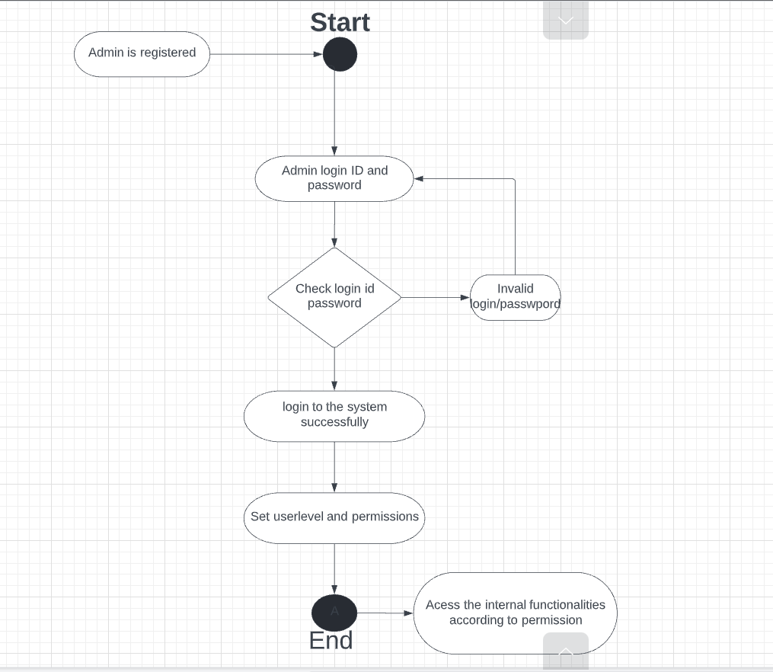

Figure 3. UML of Login

# RESEARCH OBJECTIVES

The proposed research is aimed to carry out manual bus reservation system to online bus reservation system where people can book their bus sitting at their home without standing in lines for hours to buy bus ticket .The proposed aim will be achieved by dividing the work into following objectives:

1. To overcome this purposed solution we have to work with PHP,HTML,JAVASCRIPT,SQL and may be some other framework.

2. To study and analyze various techniques that are suitable for online bus reservation system discovery.

3. To design and develop the technique for code and login page ,booking page ,PNR enquiry etc.

4. To analyze and design various methods to payment method in the program. 5. To verify and validate the proposed system.

**4.1 Analysis**

Analysis is detailed study of the various operations performed by a system and their relationship

between within and outside is collected on the available files decision and transaction handled by the present system. All the logical aspect of the system is conversed in the phase. Analysis is the most important phase in the system of a system. In analysis phase one has to study the existing system in detail and also collect necessary information regarding the system to be designed. Hence in this phase Uml diagrams are made indicating the data flow in the system, and then only can a system be made correct otherwise it will be incorrect. Analysis is conducted with the following objective in mind:

* Identify the customer needs.
* Evaluate the system concept for feasibility
* Perform economic and technical analysis.

• Identify the customer need.

• Evaluate the system concept for feasibility.

• Perform economic and technical analysis.

• Technical Feasibility

• Economic Feasibility

• Behavioral Feasibility

# METHODOLOGY

The following methodology will be followed to achieve the objectives defined for proposed research work:

* 1. In order to start with web development project one needs to install visual studio code in which the code will be written.
  2. We can install VS code Microsoft visual studio official website with any version at least 5.11.
  3. We need to install XAMPP control panel for making our project work as it comes with all the localhost server that are needed to perform the functions.
  4. We need to link all the reference like bootstrap and google fonts and many more in Index.php code itself so that all the frameworks work properly.

**5.1 Project design**

We have planned this project over a period of 30 days and divided it into four iterations. We planned the first iteration for analysis, second iteration for bus reservation system design, third iteration for coding and the final iteration for the product.

Setting off for a journey usually requires planning -- for instance, it is good to know what destination you want to reach and what stops you will make along the way. We do the same in programming. Before jumping into writing code, we pseudo-code: we write steps we will take and goals we want to achieve. The general procedure for Bus Reservation system looks like:

* Create a login page to grant access to the customer to book his/her bus.
* Create the payment gateway for the website.
* Allow the customer to choose his choice of seat.
* To collect the data of buses around the nation and their routes
* To provide status of bus arrival and departure to the passenger
  1. **PROJECT SNAPSHOTS**
     1. **Login Page**

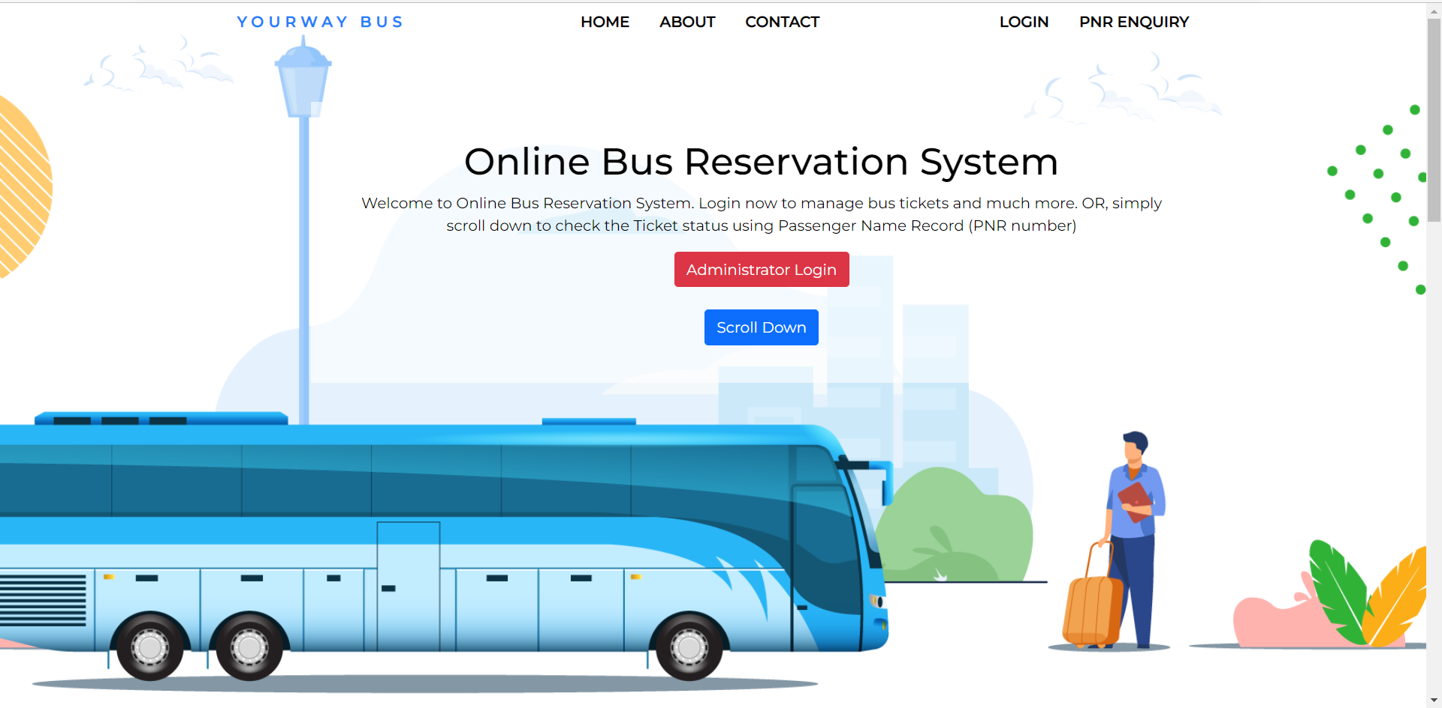

* + 1. **PNR ENQUIRY**

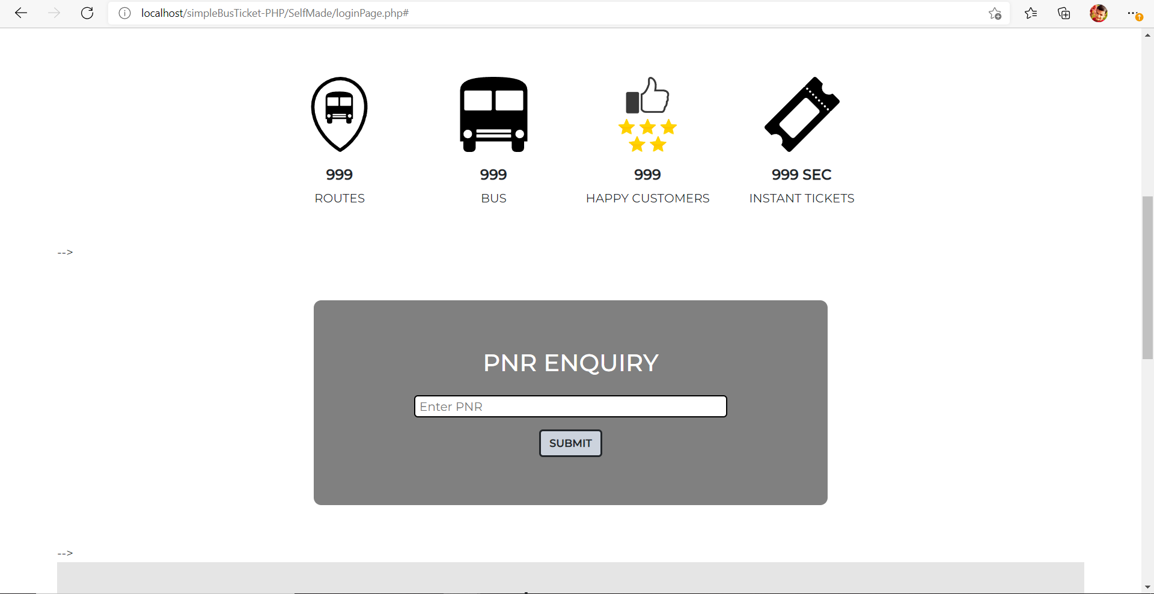

* + 1. **Query Box**

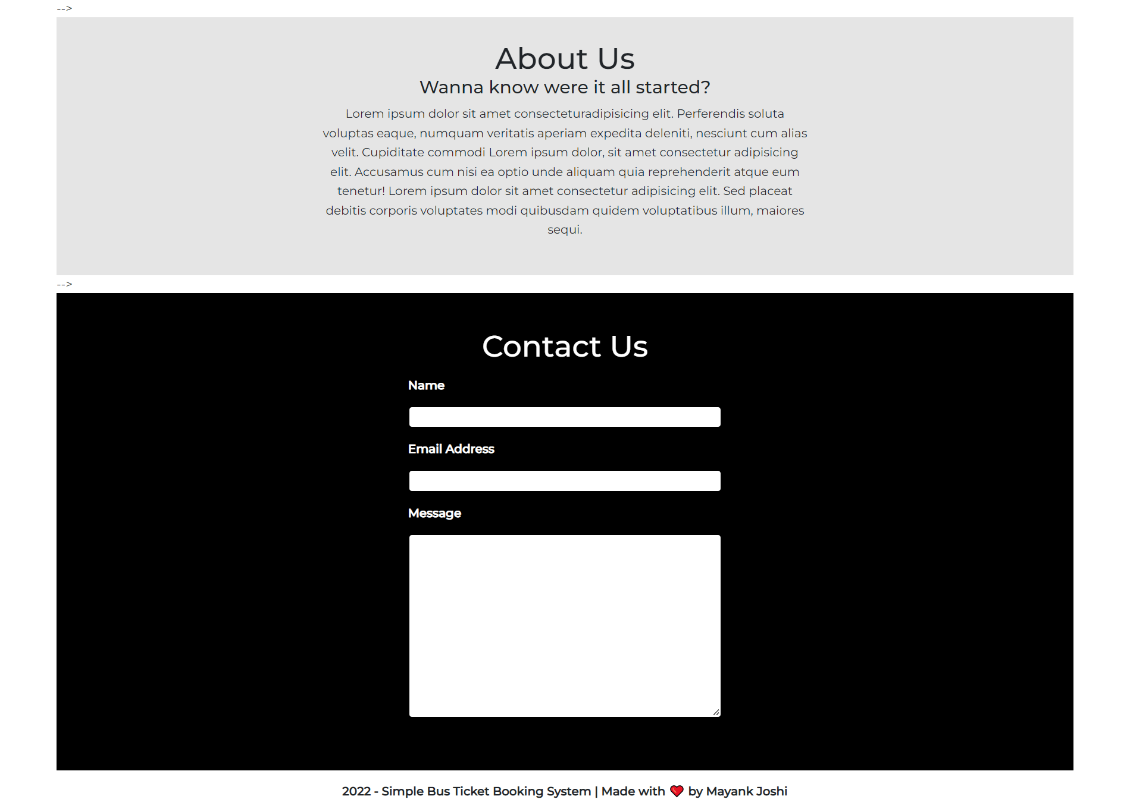

* + 1. **Admin Page**

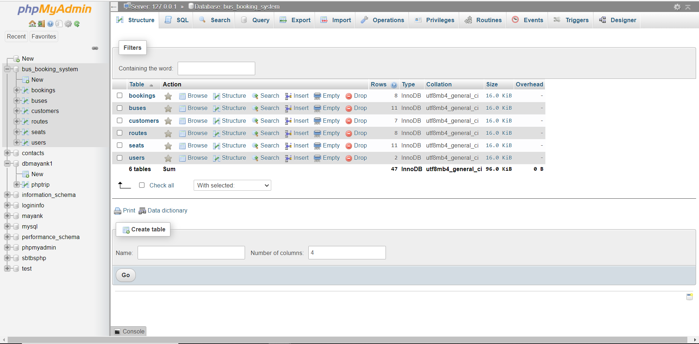

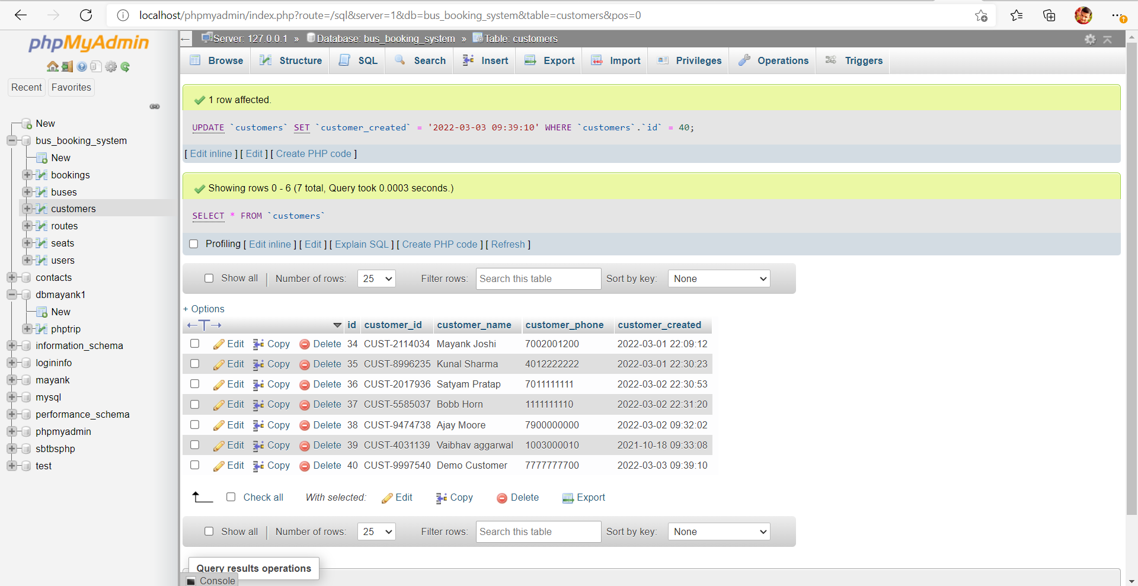

1. **RESULTS AND DISCUSSION**

Bus reservation system is most familiar among all the age groups. Intelligence can be a property of any purpose-driven decision maker. This basic idea has been suggested many times. An algorithm of playing Bus reservation system has been presented and tested that works in efficient way. Overall, the system will work efficiently . Our project is only a humble venture to satisfy the needs to manage their project work. Several user-friendly coding and web development has also been adopted. The objective of the software planning is to provide a framework with a limited project completion time frame at the beginning of the project and should be updated on a regular basis.

These results suggest that both importance and predictability play a role in the acoustic realization of a word. Duration is longer and pitch movement is greater for non-predictable words while intensity is greater for important words.

One potential concern is that the effects of intensity may have been the result of paralinguistic factors such as emotional excitement related to use of booking system . How one might distinguish between the linguistic and paralinguistic factors that drive prominence is a question of considerable debate. Moreover, the speaker’s personal reaction to the importance of their utterance is not inconsistent with the proposal that importance drives acoustic prominence.

**6.1 future work**

* To Develop android app for this Web Based application
* To minimize the loading time.
* To provide guided videos on how to use the application.
* To include GPS tracker
* TO provide notifications related bus details.

# REFERENCES

1. <https://www.w3schools.com/php/php_mysql_connect.asp>
2. <https://www.w3schools.com/php>..
3. <https://www.w3schools.com/js/default.asp>
4. <https://www.w3schools.com/graphics/svg_intro.asp>
5. <https://www.w3schools.com/bootstrap/bootstrap_ver.asp>
6. <https://www.w3schools.com/html/default.asp>